Virtual hard disk size 4000MB.

The previous step was succesful now I have a virtual computer, with a virtual CDROM in a virtual drive.

Installation successful!

Network, mouse, keyboard works fine.

Haaga-helia website works!

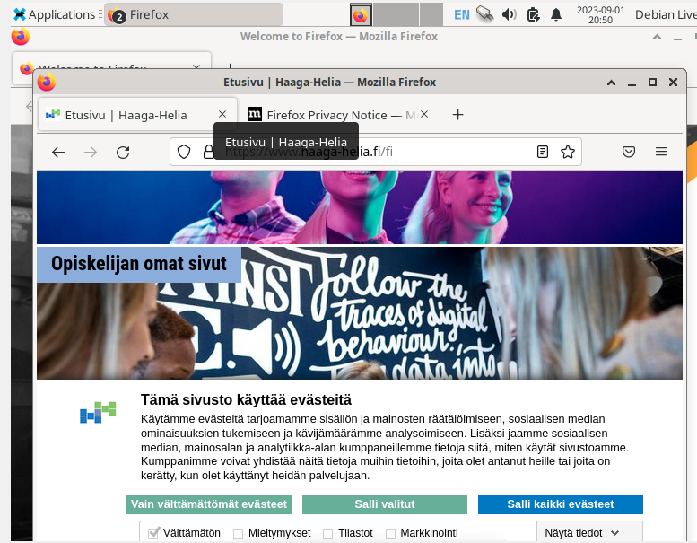

Debian installation process initiated.

* Region > Helsinki
* Keyboard > Finnish

Then I chose – erase disk option

User credentials – ok

Summary – ok > installation started

After installation and first log in everything works still.

The command executed successfully.

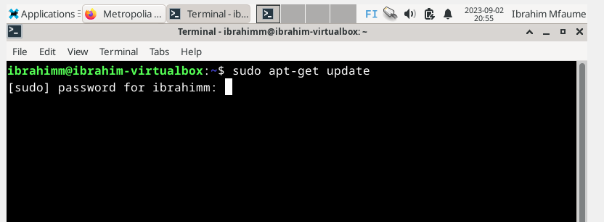

$ sudo apt-get -y dist-upgrade this code ran successfully too.

Everything upgraded and firewall enabled.

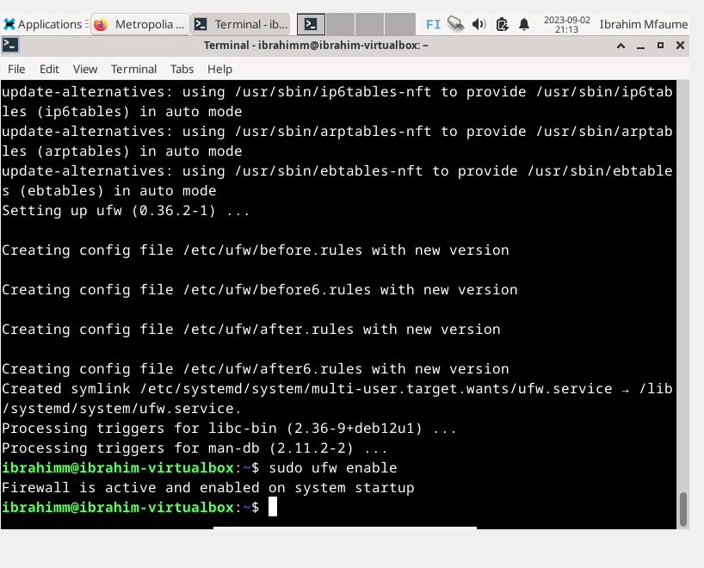

Guest additions installed. Success!

